Billingford, Elstree Hill 21/01294 Revised

We object to this revised planning application. While the site could be redeveloped, and the reduction from 4 to 3 houses is welcome, the proposal remains unacceptable for reasons previously stated.

Sensitive site
Our continuing concern about this proposal, albeit revised, is the impact on this very sensitive site which is part of the South East London Green Chain and to which Local Plan Policy 54 applies.
The top part of Elstree Hill is known and loved for its unusual and rare rustic and sylvan appeal. Whilst the current owner has significantly damaged this by removing much soft landscaping, an appropriate development would allow for much of this to be restored. The current, revised proposal significantly detracts from the feel, and indeed the appeal, of the street scene and would lead to much ‘hardening’ of the streetscape.

Dominant main elevations
The revised proposal at this sensitive corner site would have very prominent 3 storey gables and a large bland flank wall very close to the curtilage. This, together with a significant increase in bulk and mass close to the road, would completely change the character of the plot. New on-site car parking, driveways and minimal opportunity for soft landscaping would also harden the streetscape.

South East London Green Chain Bromley Local Plan Policy 54
This proposal would harm the character and function of the Green Chain by increasing the sense of urbanisation in this section of the road. There is little possibility of effective screening to maintain the sense of being in a green corridor as there would be little free land at the front of the properties.

Relationship to No 27 Elstree Hill
We are pleased that previously noted concerns about overlooking of 27 Elstree Hill have been addressed by this revised proposal.

Soft landscaping
There is a lack of space for any meaningful soft landscaping at the front (and indeed no landscaping plan has been submitted). This would further erode the sylvan quality of this end of Elstree Hill.
Building close to established trees would result in pressure to fell them in due course which would also erode the street scene.

Street scene in Kirkstone Way
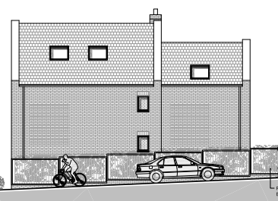
The bland flank wall close to Kirkstone Way would increase the sense of enclosure in this narrow road and thus be detrimental to the appearance and character of that road as was noted in Para 5 of the Appeal Decision APP/G5180/W/15/3135093 regarding application DC/15/01673/FULL1.

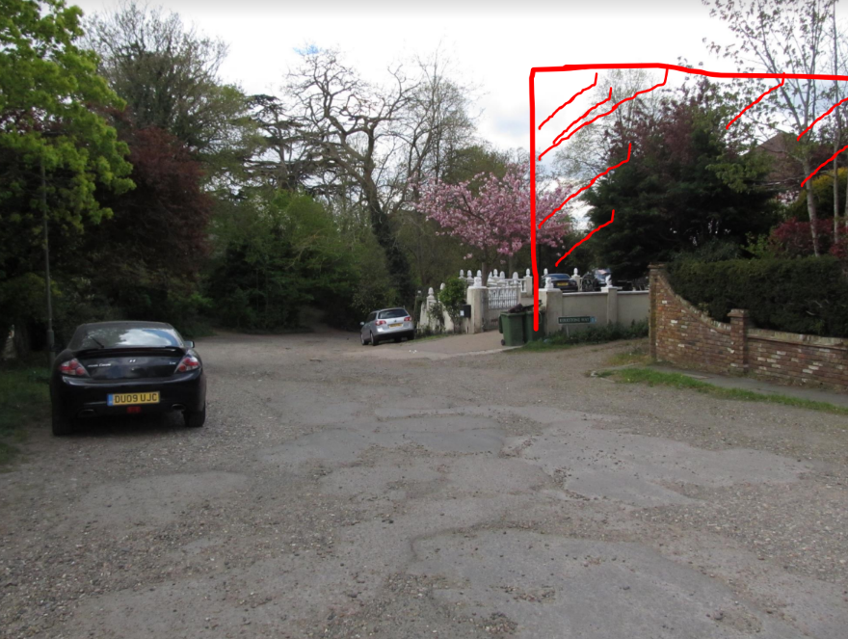
Above: the dreadful elevation to Kirkstone Way and its impact on the Elstree Hill street scene.

Overdevelopment
Overall, the proposed negative impact on the street scene suggests that, because of the particularly sensitive nature of this corner plot, the proposal is in fact an overdevelopment of the site.

Solutions
We believe it is possible to develop this site through making further revisions.
First, any new buildings need to be ‘pushed backwards’ into the plot to allow for screening by way of significant trees and shrubs on the front boundary. However, care would be needed to prevent overlooking of 27 Elstree Hill.
Secondly, the quality of the buildings needs to be significantly improved in order that they be a very genuine and positive enhancement in the street scene and one which people could genuinely enjoy – in other words the proposal needs to be beautiful. (‘Living with Beauty’, The report of the Building Better, Building Beautiful Commission refers)
We make some suggestions below and, without prejudice, should the Council by minded to give permission, we would ask that Conditions be applied which ensure the very highest quality of materials and design.

The following are suggestions for making the proposal architecturally interesting: -

Our proposals for enhancement | Developer’s proposals
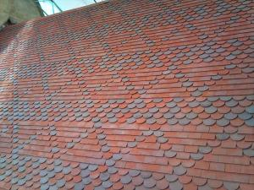 | 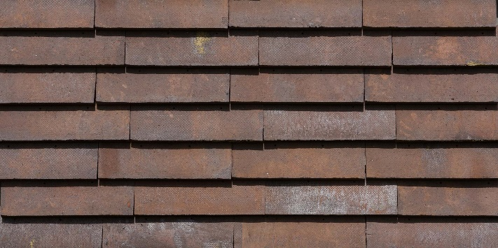
- Attractive tiling pattern | Proposed Peterson C48 tiles - boring, unattractive pattern
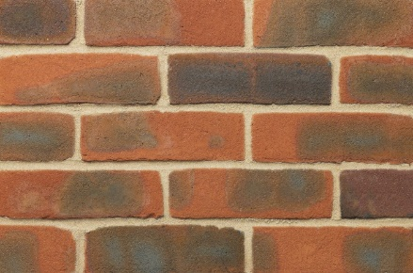 | 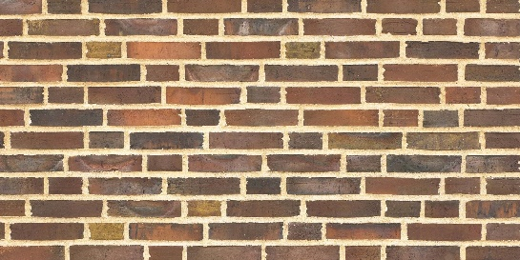
- Attractive brick work  (Hampshire Stock Red Multi ATR Bricks From MBH PLC | Image of proposed Peterson D48 brick. Ugly imposing mortar lines

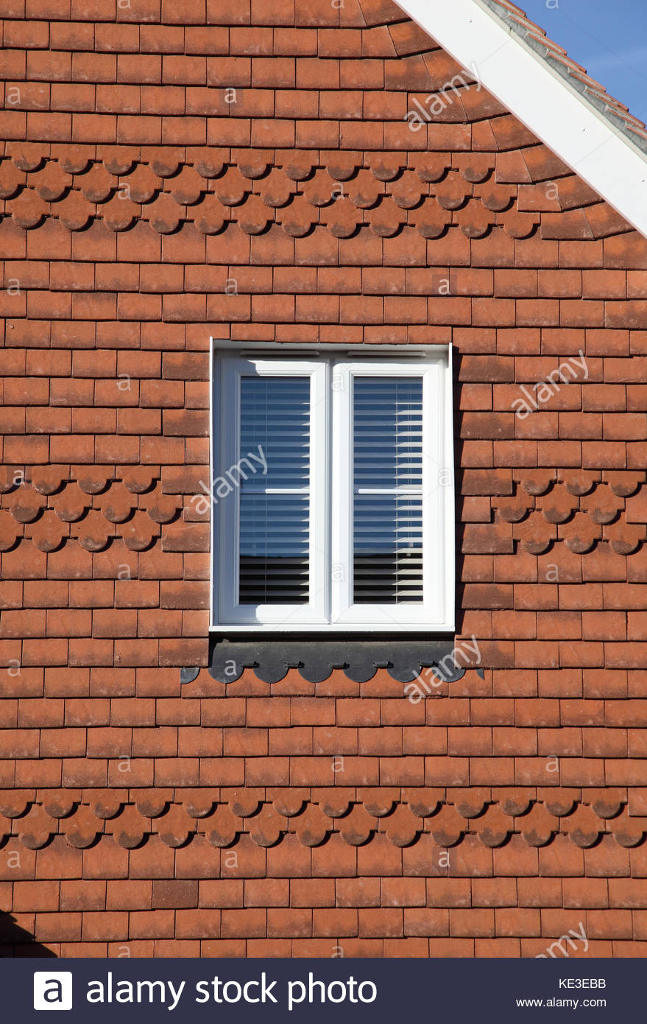 | 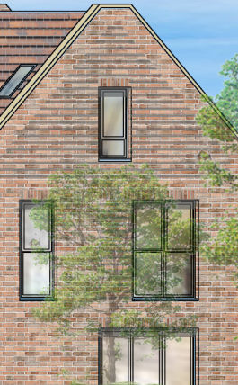
- interesting wall hangings(and cill) | Developer proposes somewhat bland principal elevation
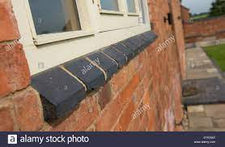
- Insert a more defined cill | Developer proposes an unattractive minimalist design
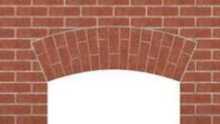 | 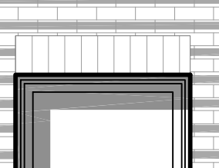
- Insert more attractive arch | Developer’s proposed arch is boring
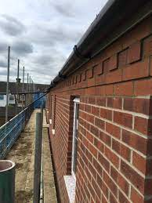
- Insert dentil course for interest

Conditions
In addition to the comments above, we would also ask that were permission to be granted, that conditions be full, comprehensive, and precise. We are mindful that there have been significant enforcement issues at this property in the past and we believe that it will be important to carefully control any future development by way of clear conditions.
Yours faithfully

Clive Lees
Chairman
Ravensbourne Valley Residents
Latest news | About us | Join us | Twitter |
c/o 38 Warren Avenue, BR1 4BS

