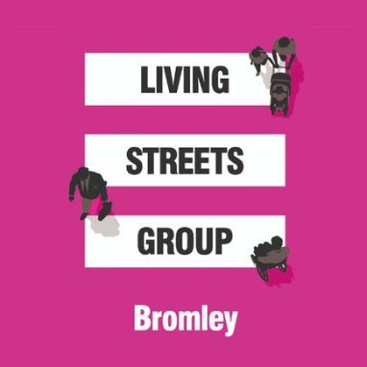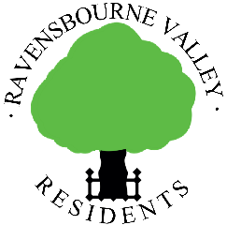

Dear Resident,

Local traffic survey

Some residents are concerned that the increase in flow, speed and noise of traffic on local roads is having a negative impact on the lives of residents particularly with regard to safety and pollution, and possibly also property values. This survey seeks your opinions to support efforts to tackle these issues. Please tick or circle your responses to the questions below and write additional comments in the space provided. A digital version can be found here: - https://www.ravensbournevalley.org/Traffic-Survey-Downloads.php

1. Your name and address
Click or tap here to enter text.

2. Are any of the following issues for you on your road? Parking ☐
Volume of traffic ☐
Speeding ☐

Please add a comment if necessary: -
Click or tap here to enter text.

3. How do you feel about the speed of traffic on your road?
A. It’s fine. ☐
B. Mildly irritating, no action required. ☐
C. A significant problem, action is required. ☐

Please add a comment if necessary: -
Click or tap here to enter text.

4. Would you be interested in considering any of the following speed reduction measures on your road? (Details of these measures can be found here: http://content.tfl.gov.uk/achieving-lower-speeds-toolkit.pdf)

  - New signs, lines and other road markings (e.g. painting ‘30mph’ on the road). Yes ☐ No ☐

  - New vehicle activated signs (e.g. in addition to the one installed recently). Yes ☐ No ☐

  - Speed indicators and flashing beacons (e.g. a sign that flashes the driver’s speed). Yes ☐ No ☐

  - Virtual speed humps (road markings that look like a speed hump). Yes ☐ No ☐

  - Road humps, speed cushions or raised tables (road humps and raised tables go across the whole road, speed cushions allow buses or emergency vehicles to pass unhindered). Yes ☐ No ☐

  - Chicanes (e.g. using islands or physical buildouts, which could take the form of planters, parklets or strategically positioned trees). Yes ☐ No ☐

G. Traffic islands and pedestrian refuges. Yes ☐ No ☐

- Narrowing the road along its whole length (e.g. by introducing median strips, adding cycle paths or segregated cycle lanes, widening footpaths or adding a ‘grassy verge’ to one or both sides of the road). Yes ☐ No ☐

- Modal filter (e.g. adding a gate or bollards, either at one end of the road or halfway along its length, in order to stop all motor traffic using the road as a cut-through – addition of a bus gate would mean the only motor traffic able to travel through would be public transport and emergency vehicles). Yes ☐ No ☐

Please add a comment if necessary: -

Click or tap here to enter text.

5. Would you be interested in storing your bicycle in a cycle hangar on your road? (A cycle hangar is a safe, covered place to park a cycle. There are over 7,200 spaces across 25 London boroughs.) Yes ☐ No ☐

6. Are there any traffic issues you would like to mention on roads nearby other than your road?

Click or tap here to enter text.

7. Would you be interested in receiving occasional updates on discussions with the council on this topic and other issues which RVR deals with? If yes, please provide an email address. Click or tap here to enter text.
Please refer to our privacy notice here https://www.ravensbournevalley.org/privacy-policy.php
Please return this completed survey by 31st January 2021 to either Brendan Donegan at 7a Farnaby Road or digitally to roadsandtransport.rvr@outlook.com – and thank you for your time!

Thank you for your help

Clive Lees Brendan Donegan
Chairman Chairman
Ravensbourne Valley Residents Bromley Living Streets

