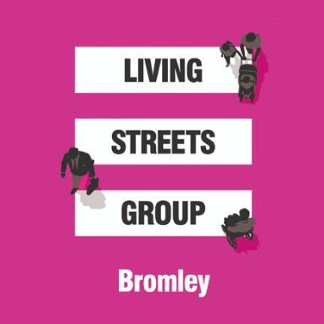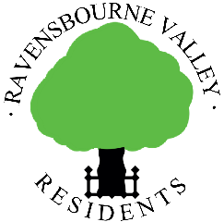

Dear Resident,

Traffic in Bromley Avenue

We have become increasingly concerned about traffic issues in Bromley Avenue. The increase in flow, speed and noise of traffic on the road is having a negative impact on the lives of residents particularly with regard to safety, amenity, pollution and even, anecdotally, to the point of having a detrimental effect on property values.

In consequence, we are interested in your opinions to support our approaching Bromley Council to seek mitigation of these issues.

With this in mind, we would appreciate your answers to this short questionnaire.
- Your name
Click or tap here to enter text.
Your address
Click or tap here to enter text.

- Are you troubled by traffic noise from: -
Often Sometimes Rarely Never
a) Cars? ☐ ☐ ☐ ☐
b) Motorcycles? ☐ ☐ ☐ ☐

- If so, are there specific times when you feel that it’s worse than others? Please provide details.
Click or tap here to enter text.

- Have you experienced damage to your vehicle(s)? (e.g. wing mirrors)
Click or tap here to enter text.

- Have you witnessed dangerous driving? (please give examples)
Click or tap here to enter text.

- Would you be in favour of traffic-calming measures in Bromley Avenue?

Yes ☐ No ☐

If yes, what would you like to see?

Click or tap here to enter text.

- With regard to traffic turning into Bromley Avenue from Grasmere Road: -

Have you seen examples of bad driving at this junction? Yes ☐ No ☐

If yes, please give details.

Click or tap here to enter text.

- If yes to question 7, have you any suggestions as to how this junction might be improved?
Click or tap here to enter text.

A digital version of this form can be downloaded from https://www.ravensbournevalley.org/Traffic-Survey-Downloads.php

Please return this completed survey to either Jane Willcocks at 11 Bromley Avenue or digitally to roadsandtransport.rvr@outlook.com by 31st January 2021.

Thank you for your help

Clive Lees Brendan Donegan
Chairman Chairman
Ravensbourne Valley Residents Bromley Living Streets

